HTML classes

**Table of content**

* What is the definition of class in HTML?
* What is a use of HTML classes?
* How to make a class in HTML?
* Explain the concept of multiple classes in HTML?
* What is a concept of external class?

**What is the definition of class in HTML?**

Class is a block of code which is defined outside the body tag and call within the body tag. Class can be represented by dot (.) class-name. Class can be defined under style tag in the header section of the document.

In HTML, class concept is use for defining and declaring the more than one attribute within the one block of element. The class can be call within the main body so that if more than one attribute has to be given on more than one element then it will be easy to apply and understand the code. Class mainly the concept use in styling the sheet and this concept is also use to increase the reliability of the code.

NOTE-

Class can be call under any HTML element.

**Syntax-**

<style>

. Classname {

Attribute: value;

}

<style>

**Example-**

<!DOCTYPE html>

<html lang="en">

  <head>

    <meta charset="UTF-8" />

    <meta name="viewport" content="width=device-width, initial-scale=1.0" />

    <title>Document</title>

  </head>

  <style>

    .myclass {

      background-color: rgb(245, 229, 11);

    }

    .myclass1 {

      text-align: center;

    }

  </style>

  <body>

    <h2>how to define class?</h2>

    <p class="myclass">

      Class can be define within the header section of the document and can call

      by any HTML element.<br />

      here, I have created 2 classes and apply text alignment as well as

      background color attribute in it.

    </p>

    <h4 class="myclass1">Thanks</h4>

  </body>

</html>

**Output-**

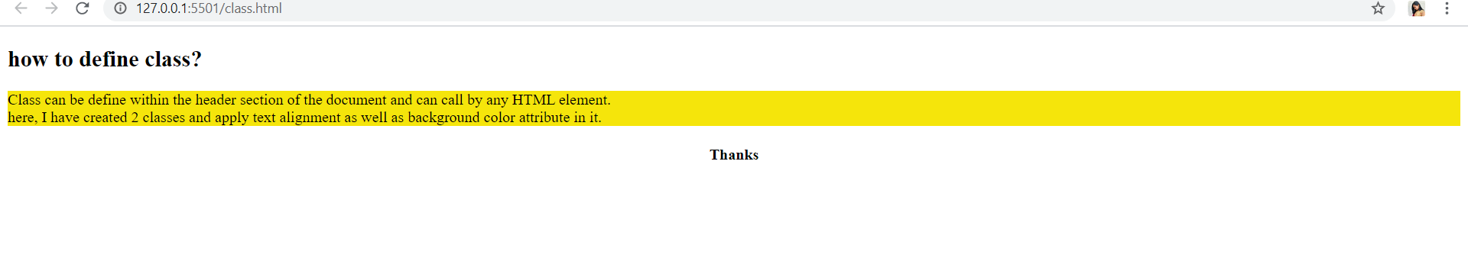

**What is a use of HTML classes?**

Class concept in HTML is use for defining more attributes within the single block of code. This concept is really very important at the time of creation of style-sheet in the document. All the elements in the HTML document will support to the Class. Class allows us to access multiple elements in the document with the help of JavaScript.

**How to make a class in HTML?**

Example of class with div element-

**Example-**

<!DOCTYPE html>

<html lang="en">

<head>

    <meta charset="UTF-8">

    <meta name="viewport" content="width=device-width, initial-scale=1.0">

    <title>class element</title>

</head>

<style>

    .firstclass {

        color: rgb(248, 77, 162);

        font-family: 'Franklin Gothic Medium', 'Arial Narrow', Arial, sans-serif;

        font-style: italic;

        text-align: center;

        background-color: rgb(247, 226, 218);

    }

</style>

<body>

    <div class="firstclass">

        <h1>example of class by using div</h1>

        <p>here i have added color, font family, font style and text alligment in the class </p>

        <h4>Thank you</h4>

    </div>

</body>

</html>

**Output-**

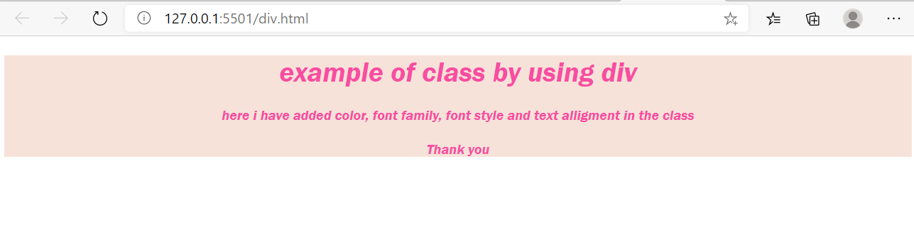

Example of span with class-

**Example-**

<!DOCTYPE html>

<html lang="en">

<head>

    <meta charset="UTF-8">

    <meta name="viewport" content="width=device-width, initial-scale=1.0">

    <title>class element</title>

</head>

<style>

    .myfirstclass {

        color: red;

        font-family: 'Franklin Gothic Medium', 'Arial Narrow', Arial, sans-serif;

        font-style: oblique;

        text-align: center;

    }

</style>

<body>

    <h1>example of<span class="myfirstclass"> class by using span</span></h1>

    </div>

</body>

</html>

**Output-**

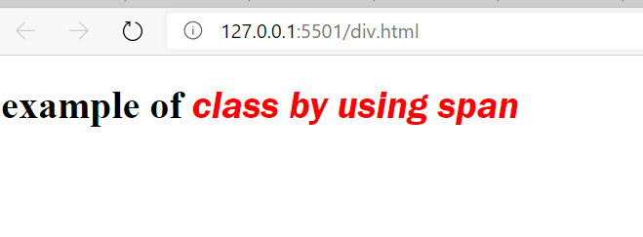

**Explain the concept of multiple classes in HTML?**

In HTML document user can create more than one class. For creating multiple classes, Class with proper attribute for styling the document is only required. Class can allows the user to call the class block within only one element or can apply on the all the elements within the document.

**Example-**

<!DOCTYPE html>

<html lang="en">

<head>

    <meta charset="UTF-8">

    <meta name="viewport" content="width=device-width, initial-scale=1.0">

    <title>class element</title>

</head>

<style>

    body.myclass {

        background-color: rgb(241, 209, 185);

    }

    .myfirstclass {

        color: rgb(51, 3, 3);

        font-family: 'Franklin Gothic Medium', 'Arial Narrow', Arial, sans-serif;

        font-style: oblique;

        text-align: right;

        text-transform: capitalize;

    }

    .mysecontclass {

        color: rgb(115, 146, 212);

        font-family: Georgia, 'Times New Roman', Times, serif;

        font-style: italic;

        text-align: left;

    }

    .mylastclass {

        color: saddlebrown;

        font-family: Arial, "Helvetica Neue", Helvetica, sans-serif;

        letter-spacing: 1cm;

        text-align: center;

    }

</style>

<body class="myclass">

    <h1 class="myfirstclass">my first class</h1>

    <h1 class="mysecontclass">my second class</h1>

    <h1 class="mylastclass">my last class</h1>

</body>

</html>

**Output-**

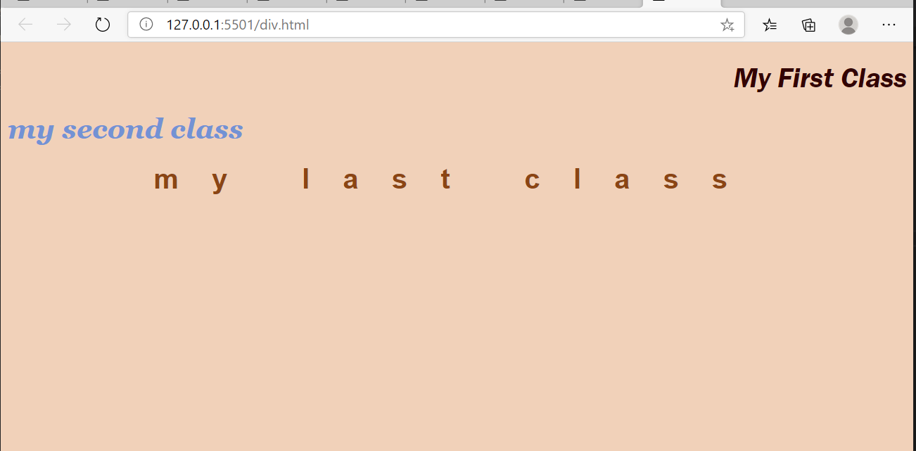

**What is a Concept of external class?**

External class is a concept of defining a class outside the HTML document. For defining the class it is required to define a class in a separate CSS file and then call the class properties into the main HTML document. It is a best practices when there are many element or files required to define many formatting properties then this concept is use.

**Example of External class-**

In the below example, Class is define in a separate style-sheet. Make sure that while defining the class properties in CSS file must be save as (.CSS ) Extension. Otherwise it will not work.

.class {

  text-align: center;

}

.myclass {

  background-color: rgb(247, 239, 127);

  color: rgb(141, 29, 29);

  font-family: "Franklin Gothic Medium", "Arial Narrow", Arial, sans-serif;

  font-style: oblique;

  text-align: center;

  text-transform: capitalize;

}

.myclass1 {

  text-align: center;

}

**Main HTML document-**

<!DOCTYPE html>

<html lang="en">

  <head>

    <meta charset="UTF-8" />

    <meta name="viewport" content="width=device-width, initial-scale=1.0" />

    <title>class example</title>

  </head>

  <link rel="stylesheet" href="class.css" />

  <body>

    <h2 class="class">how to define class?</h2>

    <p class="myclass">

      Class can be define within the header section of the document and can call

      by any HTML element.<br />

    </p>

    <h4 class="myclass1">Thanks</h4>

  </body>

</html>

**Output-**

